

**Design Studio #4 - Weekly Progress Report #10**

DS Instructor: Gülbin DURAL

Partners:

* Fatih ÇALIŞ
* Fatih ÇAM
* Recep GÜNAY
* Huzeyfe HİNTOĞLU
* Sarah ILYAS

At the 1st week of the spring semester, we decided to print some crucial parts of our robot. One of them is the bracket which is responsible for keeping DC motors fixed. Since the DC motor that we have chosen is very widely-used, there are lots of 3d models on the Internet for the same purpose. To make sure that it can handle high forces, we preferred the one with the 4 screw holes, which is shown in the Figure1.

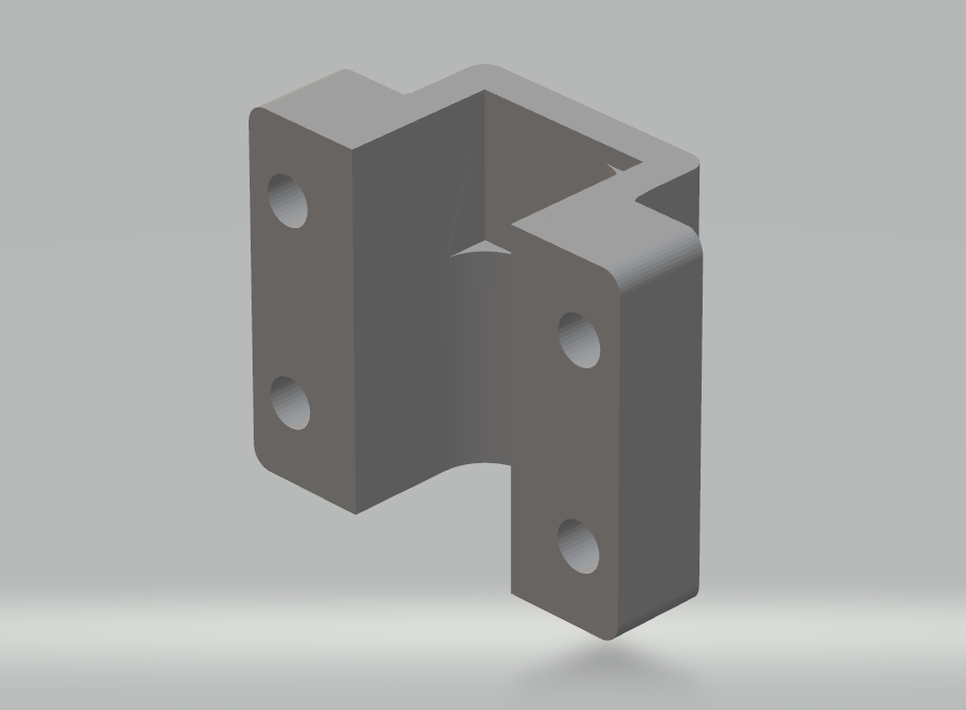

*Figure1: The 3D model of the DC motor mount*

The second and more important part of the robot is the spiral shaped component, which is the base of the shooting mechanism. It is expected to be strong enough since the shooting rod will generate a large force on it. At the same time, this spiral needs to be as lightweight as possible since as its weight increases, the required torque generated by the DC motor also needs to increase. Due to these specific conditions, we decided to draw its model as shown in Figure2 using Autodesk Fusion software.

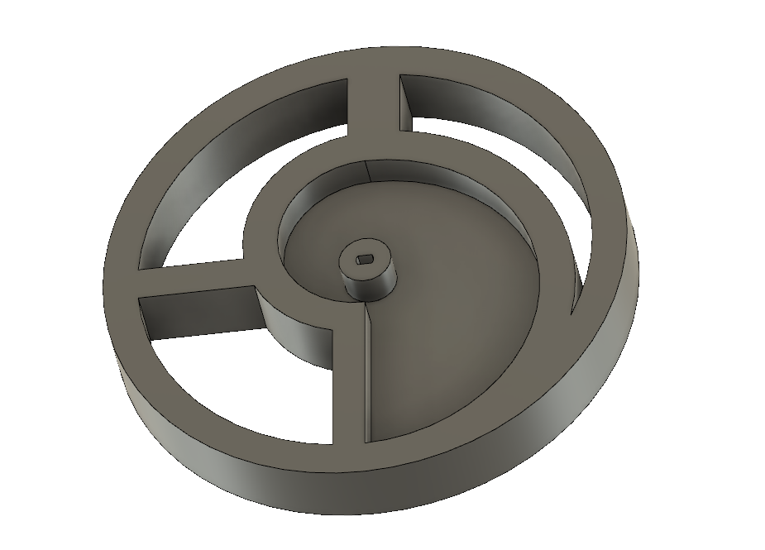

*Figure2: The 3D model of the spiral part of the shooting mechanism*

In the following week, we are planning to integrate the mechanical components of the robot since it is a must for the test and implementation of other subsystems. (Fatih ÇALIŞ)